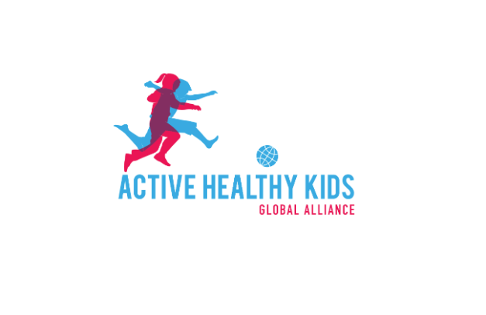
Global Matrix 5.0 Publication Plan
Expression of Interest Form
The Active Healthy Kids Global Alliance (AHKGA) publication plan for the Global Matrix 5.0 was developed by the AHKGA Publications Committee and presented at the AHKGA webinar on March 26, 2025. Expressions of interest to contribute to “global” publications should be sent by email to salome_aubert@hotmail.fr & estone@cheo.on.ca and are due no later than May 31, 2025. Submissions will be reviewed by the AHKGA Publications Committee and applicants will be contacted no later than June 2025 for future publication planning.
To express your interest, please provide the following information:
Name:
Represented Report Card team (country/jurisdiction):
Report Card role (leader, co-leader, team member):
Contact email:
Affiliation(s):
Professional bio (up to 300 words):
Paper of interest (please remove the irrelevant ones from the list below, only one paper can be selected):
- Global Disability paper
- Organized sports
- Active Play
- Active Transportation
- Sedentary Behaviours
- Physical Fitness
- School
- Family and Peers
- Community and environment
- Government

Relevant publications (up to 5 most relevant papers):

Suggested additional points of analysis of discussion for the paper:
Note: There will be consistent content across papers (e.g., overall findings and exploring surveillance & standardisation challenges, equities and inequities – at multiple levels country, region, gender, disability, research gaps, priorities and recommendation). Here we are interested in your potential suggestion for additional specific analysis, links, discussions that would be relevant for the specific paper of your interest.

Additional comments:

